SIMATS ENGINEERING (SAVEETHA SCHOOL OF ENGINEERING)
Department of Computer Science and Engineering

ASSESSMENT TOOL 3 – Technical Presentation

Course Code: | CSA0305 | Course Title: |  | Data Structures
 | CO1 – Imitation (BL3, BL4)
 |  |  |  | Assessment Tool 3 – Technical Presentation
CO Assessed: |  | Assessment:
 | 35% of CIA
 |  |  |  | 100
Weightage: |  | Total Marks:
CO1 Statement: | Apply suitable data structures and ADTs for efficient problem solving by analyzing time and space complexity.
Student Name: | J. MEHER KOUSHIK |  | Reg. No.: | 192525211
 | AI&ML
 |  |  |  | 15/07/2026
Section / Batch: |  |  | Date:

Code of Conduct
I J.MEHER KOUSHIK(192525211) certify that this submission is my original work and that I have adhered to the guidelines specified for this assessment. I understand that any violation of academic integrity rules will result in disciplinary action. Signature of the Student: J.MEHER KOUSHIK

Instructions
- This assessment contains technical presentation. Total: 100 Marks.
- When a student delivers a technical presentation on a data structures topic, evaluation should be based on the following requirements: Concept explanation, Real-world application and Clarity of presentation. • Demonstrate clear understanding, not just reading slides
- Use of tools: PowerPoint / Google Slides.
- Duration: 7–10 minutes presentation + 3 minutes Q&A.

Section / Topic

Focus

Q Nos

Marks

Data Structure

Real
-
Time Applications

1

100

GRAND TOTAL:

100
Marks

Annexure A – Technical Presentation

A web browser supports navigating backward through previously visited pages. Recommend a suitable ADT and prepare a technical presentation explaining how it improves performance
efficiency. (100 Marks)

(OR)
A music streaming application maintains a playlist where songs can be added, removed, or reordered dynamically. Recommend a suitable data structure and justify based on flexibility and efficiency. Prepare a technical Presentation. (100 Marks) (OR)
A metro rail network maps stations and routes to determine reachable stations from a source station. Suggest a suitable data structure for representation and justify your answer. (100 Mark)
(OR)
A calculator application evaluates arithmetic expressions entered by users. Recommend a suitable data structure and justify based on expression processing efficiency. (100 Marks) (OR) A cafeteria token system serves customers strictly in the order of arrival. Identify the suitable
ADT and justify why it ensures fairness. (100 Marks)
Rubrics for Calculation
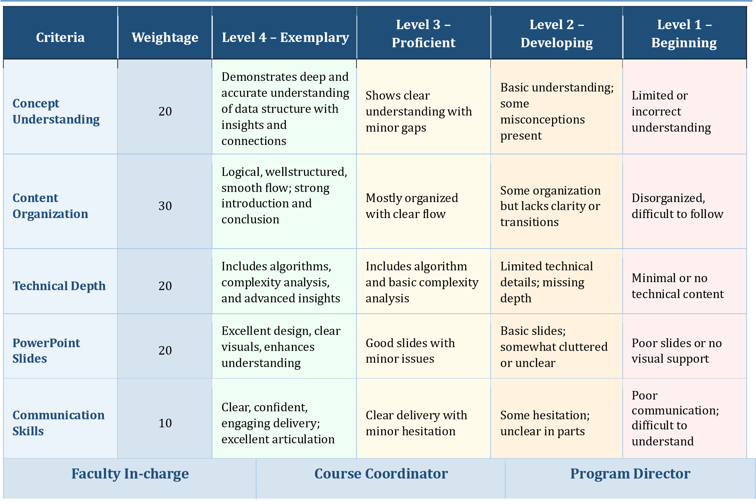
Signature: _______________ | Signature: _______________ | Signature: _______________
Date: ___________________ | Date: ___________________ | Date: ___________________

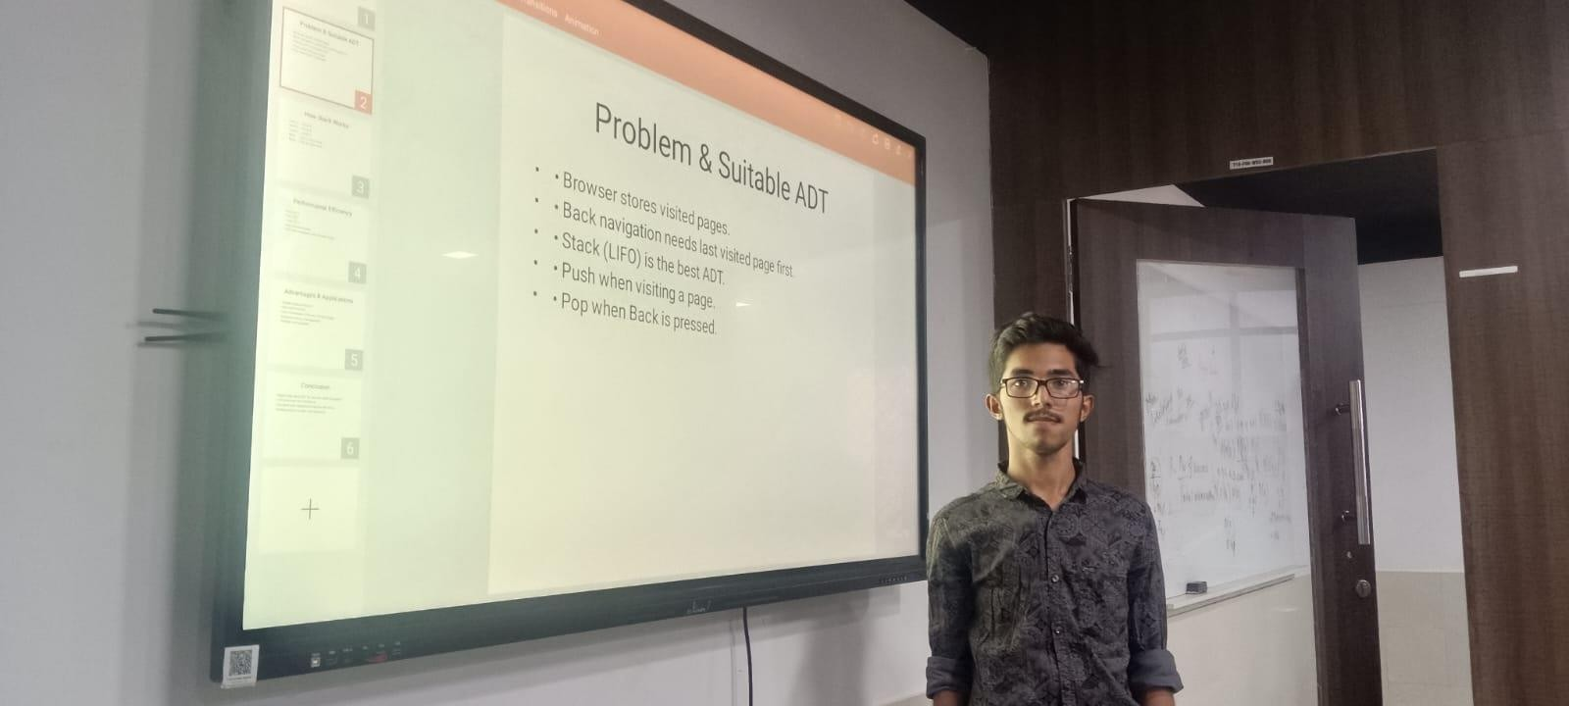

ABSTRACT:

Modern web browsers allow users to move backward through previously visited web pages quickly and efficiently. This functionality is best implemented using the Stack Abstract Data Type (ADT), which follows the Last-In, First-Out (LIFO) principle. Whenever a user visits a new webpage, its address is pushed onto the stack, and when the Back button is clicked, the most recently visited page is popped from the stack and displayed. This approach ensures fast navigation with minimal processing time. Stack operations such as push, pop, and peek are performed in O(1) time complexity, making the browser highly responsive even when handling large browsing histories. The use of the Stack ADT also simplifies browser history management, reduces computational overhead, and improves overall performance efficiency. This presentation explains the working of the Stack ADT in browser back navigation, its implementation, time complexity analysis, and the advantages it provides in creating an efficient and user-friendly browsing experience.

